1A.

If they are staying then their chances are ⅓

Sample space would be  
  
Door 1 = 1/3

Door 2 = 1/3

Door 3 = ⅓

1B.

Sample space would be initially  
  
Door 1 = 1/3

Door 2 = 1/3

Door 3 = ⅓

But say door 3 is opened now it would be

Door 1 = 1/3

Door 2 = 2/3

2A.

> 1 - pbinom(3,10,0.1)

[1] 0.0127952

2B.

> pbinom(10, 100, 0.1, lower.tail=TRUE)

[1] 0.5831555

2C.

> ceiling(log(1 - 0.95) / log(1 - 0.1))

[1] 29

2D.

> 1 - pbinom(3,10,0.1)

[1] 0.0127952

> 1 - pbinom(2,100,0.1)

[1] 0.9980551

> 1 - pbinom(2,23,0.1)

[1] 0.4080433

> 1 - pbinom(2,25,0.1)

[1] 0.4629059

> 1 - pbinom(2,45,0.1)

[1] 0.8409571

> 1 - pbinom(2,50,0.1)

[1] 0.8882712

> 1 - pbinom(2,60,0.1)

[1] 0.9469549

***> 1 - pbinom(2,61,0.1)***

***[1] 0.9508817***

So 61

3A.

> dbinom(1, size = 5, prob = 0.13)^4 * dbinom(1, size = 5, prob = 0.13)

[1] 0.00716064

3B.

> dbinom(3, size = 5, prob = 0.13)

[1] 0.01662909

3C.

> plefty = 0.13

> p0 = dbinom(0, size = 5, prob = plefty)

> p1 = dbinom(1, size = 5, prob = plefty)

> p2 = dbinom(2, size = 5, prob = plefty)

> p3 = dbinom(3, size = 5, prob = plefty)

> p0 + p1 + p2 + p3

[1] 0.9987205

4.

> draw_histogram <- function(n) {

+

+ y <- replicate(1000, sum(rnorm(n)^3))

+

+ hist(y, breaks = 30, main = paste0("Histogram", n), xlab = "y")

+ }

>

> draw_histogram(3)

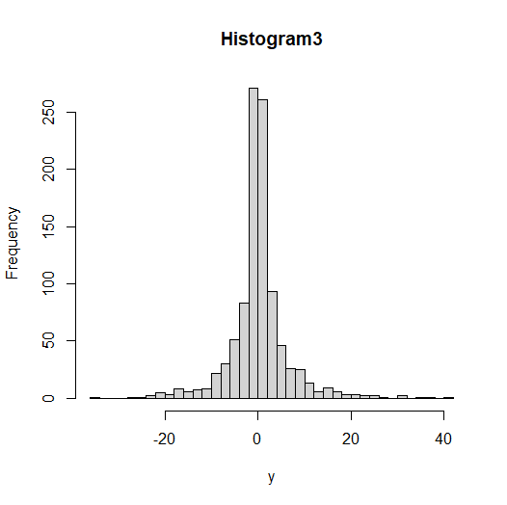

5.

> sampl <- 2 + qt(runif(1000), 4)

> hist(sampl, freq = FALSE, main = "Histo")

> curve(dt(x, df = 4), add = TRUE, lwd = 2)

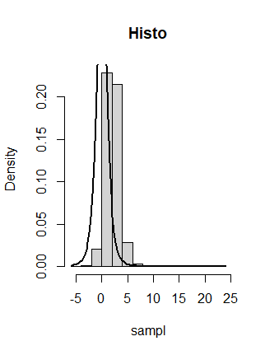

6.

Pretty sure reaction time is distributed normally,

The normal dis of reaction time shows that a majority of people have a reaction time around the mean , and that fewer people have very short or very long reaction times. Th